Supplementary Material

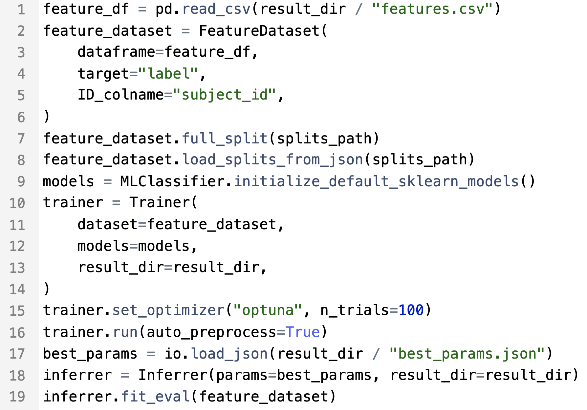
Figure S1. Example of minimal Python code executing the radiomics experiment.

Table S2. Additional evaluation for the prostate MRI datasets for differentiation between clinically significant and clinically non-significant prostate cancer.
Dataset | AUC |  | F1 | Sensitivity | Specificity
 | 5-fold CV | test | test | test | test
Prostate masks:
PROSTATEx | 0.73 ± 0.08 | 0.70 [0.33-0.97] | 0.68 [0.47-0.84] | 0.65 [0.41-0.86] | 0.75 [0.54-0.94]
UCLA | 0.48 ± 0.07 | 0.40 [0.29-0.50] | 0.13 [0.05-0.23] | 0.07 [0.02-0.13] | 1.0 [1.0-1.0]
PROSTATEx→UCLA* |  | 0.70 [0.61-0.78 | 0.77 [0.70-0.83] | 0.68 [0.60-0.76] | 0.69 [0.55-0.84]
UCLA→PROSTATEx |  | 0.48 [0.14-0.81] | 0.66 [0.40-0.87] | 0.57 [0.31-0.83] | 0.66 [0.2-1.0]
Lesion masks:
PROSTATEx | 0.67 ± 0.09 | 0.51 [0.23-0.79] | 0.56 [0.27-0.78] | 0.43 [0.18-0.71] | 0.84 [0.5-1.0]
UCLA | 0.56 ± 0.05 | 0.58 [0.46-0.70] | 0.58 [0.46-0.70] | 0.51 [0.40-0.62] | 0.70 [0.55-0.86]
PROSTATEx→UCLA |  | 0.55 [0.44-0.66] | 0.78 [0.71-0.85] | 0.83 [0.75-0.91] | 0.33 [0.18-0.48]
UCLA→PROSTATEx |  | 0.37 [0.08-0.70] | 0.77 [0.58-0.92] | 0.86 [0.64-1.0] | 0.17 [0.0-0.56]
*Arrow denotes external validation of the model trained on PROSTATEx dataset in the Prostate-UCLA dataset

Appendix S3. Details on final pipeline configuration for each task.

For each of the eight datasets evaluated, parameters including optional feature selection, ML classifier and its parameters, were tuned in 5-fold cross-validation. The final configurations are described below:
Dataset | Lipo | Desmoid | Liver | GIST | CRLM
Feature selection | Boruta | Boruta | Boruta | RFE | RFE
ML classifier | Random Forest | LogReg | LogReg | LogReg | LogReg
ML classifier parameters | n_estimators: 882,  max_depth: 2,  max_features: sqrt,  min_samples_leaf: 6,  min_samples_spllits: 3,  bootstrap: False | penalty: L1,  C:9.44 | penalty: L2,  C: 0.027 | penalty: L1,  C: 6.97 | penalty: L2,  C: 0.007
Dataset | Melanoma | PROSTATEx (prostate masks) | UCLA (prostate masks) | PROSTATEx (lesion masks) | UCLA (lesion masks)
Feature selection | RFE | RFE | RFE | RFE | RFE
ML classifier | SVM | XGBoost | SVM | LogReg | LogReg
ML classifier parameters | kernel: rbf,  C: 0.03,  gamma: 0.17,  degree: 1.0 | lambda: 3.8,  alpha: 1.4,  colsample_bytree: 0.2,  subsample: 0.95,  booster: gbtree,  max_depth: 5  min_child_weight: 8,  eta: 3.71,  gamma: 0.0002,  grow_policy: depthwise | kernel: linear,  C: 0.05,  gamma: 0.11,  degree: 1.0 | penalty: L2,  C: 0.79 | penalty: L2,  C: 0.02
*RFE – recursive feature elimination, LogReg – logistic regression, SVM – Support Vector Machine

